Integrating the Healthcare Enterprise



IHE PCC

Technical Framework Supplement

OB Labor/Delivery and Postpartum Record
(OB-LDP)

Public Comment

Date: January 22, 2009
Author: Ana Estelrich
Email: ana_estelrich@yahoo.ca or ana.estelrich@sante.gouv

This is a supplement to the IHE PCC Technical Framework V4.0.

It is submitted for Public Comment between <June 15, 2009 and July 15, 2009>.

Comments shall be submitted within that period to http://forums.rsna.org:
- Select the “IHE” forum
- Select PCC Technical Framework
- Select 2009-2010 Supplements for Public Comment
- Select OB-LPD
Please use the Public Comment Template provided there when starting your New Thread.

Details about IHE may be found at: www.ihe.net

Details about the IHE PCC may be found at: http://www.ihe.net/pcc/committees/index.cfm

Details about the structure of IHE Technical Frameworks and Supplements may be found at: http://www.ihe.net/About/process.cfm and http://www.ihe.net/profiles/index.cfm

The current version of the IHE PCC Technical Framework may be found at:. http://www.ihe.net/Technical_Framework/index.cfm

These ”boxed” instructions are for the author to indicate to the Volume Editor how to integrate the relevant section(s) into the overall Technical Framework
Replace Section X.X by the following:

TABLE OF CONTENTS

Introduction 3
Profile Abstract 3
Open Issues and Questions 4
Closed Issues 4
1.7 History of Annual Changes 5
2.1 Dependencies among Integration Profiles 5
2.2.X OB Labor/Delivery and Postpartum Record Integration Profile 5
X.1 Actors/ Transactions 6
X.2 Labor/Delivery and Postpartum Record Integration Profile Options 7
X.3 Labor/Delivery and Postpartum Record Process Flow 7
X.3 Grouping 10
X.3.1 Content Bindings with XDS, XDM and XDR 10
1.1.1 Cross Enterprise Document Sharing, Media Interchange and Reliable Messages 11
1.1.2 Notification of Document Availability (NAV) 11
1.1.3 Document Digital Signature (DSG) 11
X.4 OB-LDP Security Considerations 11
3.Y <Transaction Name> 13
3.Y.1 Scope 13
3.Y.2 Use Case Roles 13
3.Y.3 Referenced Standard 13
3.Y.4 Interaction Diagram 13

Introduction
After a patient delivers, the labor and delivery record is typically used by the postpartum and nursery/NICU units to get an overview of the labor and delivery course of the mother and delivery information regarding the newborn. This information is very useful in the postpartum care since the attending obstetrician may or may not have been present at the birth. The labor and delivery record would offer the provider the pertinent delivery information, such as complications that may need to be reassessed or require follow-up. Furthermore, in the in-patient setting for the newborn, the pediatrician would also refer to the labor and delivery record for details, such as chorioamnionitis in labor or trauma from birth, which might be pertinent for the infant’s plan of care. Continuing the mother and newborn care, a postpartum record is produced following the care administered during this period. This information is equally important as it provides a comprehensive view of the status of the mother and the new born at the time of delivery.

In some settings, public health officials are interested in the labor/delivery and postpartum information as to better monitor the mother and child’s health and intervene if necessary.

Certain data present in the labor/delivery and postpartum record is monitored anonymously as to conduct studies about the health population. The public health aspect is out of scope of this profile and it is addressed in the Mother and Child profile in the Quality, Research and Public Health domain.

Profile Abstract
The labor and delivery summary is important for care of the mother and newborn in both the inpatient and outpatient settings after delivery. Information that can affect the care of the mother and/or the newborn should be available to all care providers.. Also, the obstetric postpartum discharge summary communicates information necessary for continuing patient care of the mother and/or the newborn after delivery. The patient(s) receives a comprehensive assessment which provides the follow-up care provider with a “snap-shot” of the patient's condition at discharge.

The general administered health care workflow resulting in the collection of the information is as follows:

- Information is recorded about the labor
- A labor summary is produced
- Patient delivers in the hospital (most likely) or other setting
- A delivery summary is produced
- Care/examination is provided to the new born and the mother in the postpartum setting (most likely the hospital).
- A postpartum summary is produced
- The information about the mother and child, since standardized, can be shared seamlessly between the stakeholders. (Scope for child will only include delivery information).

The information collected varies according to the type of birthing facilities, their birthing practices and location, and also depends on the characteristics of mothers and newborns. Personnel and Health care practitioners using the information contained in the OB Labor/Delivery and Postpartum Record could be: attending physicians, resident physicians, and staff (during postpartum care in the hospital), obstetrician-gynecologists, family physicians, pediatricians, social workers, covering physicians, other medical specialists, researchers, patient safety and quality offiicers, and public health officials. The information needs to be uniform in terms of structure and content so that the document can be shared between all the stakeholders. Also, this information may also be incorporated into a patient's PHR. In some countries the OB Labor/Delivery Record is to be kept for 20 years, and it is collected by child care services, as well as public health officials for epidemiological studies.

National extensions can be produced if the regional needs are slightly different; nevertheless, the main information of the record is most likely universally the same, facilitating interoperability.

The profile OB Labor/Delivery and Postpartum Record contains data elements based on forms from various organizations, from the United States and Europe. The forms used contain:

- Demographic information about the mother, the father and the child
- General information about the family condition
- Transport summary during pregnancy (if any)
- Pregnancy Summary
- Admission to the Delivery Room (Hospital)
- Labour & Delivery Summary
- Newborn birth room record
- Newborn discharge summaryMother Discharge Summary
- Post-Partum Visit

Open Issues and Questions
< List of open issues/ questions that need to be addressed prior to publishing of the Technical Framework>
- Use case 2
- Security
- How will it be split according to the form (see APR)
- What kind of structure will the record in its entirety will have?

Closed Issues
< List of closed issues/ questions with their resolutions that have been addressed prior to publishing of the Technical Framework>

Volume 1 – Integration Profiles

Glossary
Add the following terms to the Glossary:
Anesthesia Total or partial loss of sensation, especially tactile sensibility, induced by disease, injury, acupuncture, or an anesthetic, such as chloroform or nitrous oxide.

Antepartum Of or occurring in the period before childbirth

Apgar scores A score that assesses the general physical condition of a newborn infant by assigning a value of 0, 1, or 2 to each of five criteria: heart rate, respiratory effort, muscle tone, skin color, and response to stimuli. The five scores are added together, with a perfect score being 10. Apgar scores are usually evaluated at one minute and five minutes after birth. The Apgar score is named for the system's deviser, American physician Virginia Apgar

Contraception Intentional prevention of conception or impregnation through the use of various devices, agents, drugs, sexual practices, or surgical procedures.

Contractions Obstetrics Volleys of tightening and shortening of myometrium–uterine muscle, which occur during labor, cause dilatation and thinning of the cervix and aid in the descent of the infant in the birth canal.

Delivery Expulsion or extraction of the child and fetal membranes at birth.

Erythrocytes A red blood cell that transports oxygen through the body

Gestation The period of development in the uterus from conception until birth; pregnancy.

Hematocrit The volume percentage of erythrocytes in whole blood; also, the apparatus or procedure used in its determination.

Incision A cut into a body tissue or organ, especially one made during surgery or the scar resulting from such a cut.

Inpatient A patient who is admitted to a hospital or clinic for treatment that requires at least one overnight stay.

Labor The function of the female by which the infant is expelled through the vagina to the outside world: the first stage begins with onset of regular uterine contractions and ends when the os is completely dilated and flush with the vagina; the second extends from the end of the first stage until the expulsion of the infant is completed; the third extends from expulsion of the infant until the placenta and membranes are expelled; the fourth denotes the hour or two after delivery, when uterine tone is established

Medication A drug or remedy

Myometrium The muscular wall of the uterus.

Newborn "Recently born, a neonate"

Obstetrician "A physician whose practice of medicine focuses on the care of women during pregnancy, through childbirth, and immediately following delivery. Often informally known as OB-gyn (obstetrician-gynecologist)."

Outpatient "A patient not hospitalized or housed in an extended care facility, who is being treated in an office, clinic, or other ambulatory care facility."

Pediatrician A specialist in pediatrics. Pediatrics is the branch of medicine that deals with the development and care of infants and children and the treatment of their diseases.

Postpartum Of or occurring in the period shortly after childbirth.

1.7 History of Annual Changes
<Brief overview of “what’s new” in the given year of the Technical Framework.>

Add the following bullet to the end of the bullet list in section 1.7
- Added the OB-Labor/Delivery and Postpartum Record Profile which provides the means to capture standardized information about the labor, delivery and postpartum care administered to the mother and the newborn. This information can be shared between the health care professionals and the interested parties such as social workers or public health officials.

2.1 Dependencies among Integration Profiles
Add the following to Table 2-1

OB-LPD | Antepartum Record | child | Obtain infrormation about the pregnancy.
OB-LPD | Sharing of Laboratory Reports (XD-LAB)? | child | Obtain Laboratory Results.

Add the following section to section 2.2

2.2.X OB Labor/Delivery and Postpartum Record Integration Profile This section is duplicated in X section below. Should one of these be deleted or are both sections required?
The information collected during the labor and delivery as well as during the postpartum period is very important for the follow-up care that they receive both in an outpatient setting or when the patient is transferred to a higher level of care (either high risk maternal or neonatal transport). As in the inpatient setting, the obstetrician and pediatrician need to have the pertinent information from the delivery in order to properly plan the follow-up care for the mother or newborn. For example, a mother might need a follow-up hematocrit testing or evaluation of the incision site in the office, and this information might be noted on the delivery summary. Other important information can be: delivery type, labor type and anesthesia type, postpartum complications and specific maternal information such as medications, laboratory test results, allergies and plans for contraception.Specific neonatal information, might include name, gender, birth weight, apgar scores, medications received including immunizations, etc. All this information can be obtained in the OB Labor/Delivery and Postpartum Record.

Add Section X

X OB Labor/Delivery and Postpartum Record Integration Profile
<Introductory Description/ overview of Integration Profile. May be the same as 2.2.X if that’s all it takes.>

The information collected during the labor and delivery as well as during the postpartum period is very important for the follow-up care that they receive both in an outpatient setting or when the patient is transferred to a higher level of care (either high risk maternal or neonatal transport). As in the inpatient setting, the obstetrician and pediatrician need to have the pertinent information from the delivery in order to properly plan the follow-up care for the mother or newborn. For example, a mother might need a follow-up hematocrit testing or evaluation of the incision site in the office, and this information might be noted on the delivery summary. Other important information can be: delivery type, labor type and anesthesia type, postpartum complications and specific maternal information such as medications, labs, allergies and plans for contraception.Specific neonatal information, might include name, gender, birth weight, apgar scores, medications received including immunizations, etc. All this information can be obtained in the OB Labor/Delivery and Postpartum Record.

X.1 Actors/ Transactions
There are two actors in this profile, the Content Creator and the Content Consumer. Content is created by a Content Creator and is to be consumed by a Content Consumer. The sharing or transmission of content from one actor to the other is addressed by the appropriate use of IHE profiles described below, and is out of scope of this profile. A Document Source or a Portable Media Creator may embody the Content Creator Actor. A Document Consumer, a Document Recipient or a Portable Media Importer may embody the Content Consumer Actor. The sharing or transmission of content or updates from one actor to the other is addressed by the use of appropriate IHE profiles described by section 3.7 Content Bindings with XDS, XDM and XDR found in the Patient Care Coordination Technical Framework

Figure X.1-1 Labor / Delivery and Post-Partum Record Diagram

X.2 Labor/Delivery and Postpartum Record Integration Profile Options
Options that may be selected for this Integration Profile are listed in the table X.2-1 along with the Actors to which they apply. Dependencies between options when applicable are specified in notes.

Table X.2-1 OB-LPD - Actors and Options
Actor | Options | Vol & Section
Content Consumer | View Option (See Note 1)  Document Import Option (See Note 1)  Section Import Option (See Note 1)  Discrete Data Import Option (See Note 1) | PCC TF-1: 2.13.1  PCC TF-1: 2.13.2  PCC TF-1: 2.13.3  PCC TF-1: 2.13.4
Content Creator | Referral Option (See Note 1)  Discharge Summary Option (See Note 1) | PCC TF-1: 2.13.5  PCC TF-1: 2.13.6
Note 1: The Actor shall support at least one of these options

X.3 Labor/Delivery and Postpartum Record Process Flow

X.3.1 Labour and Delivery
A 30 year-old pregnant woman (41 weeks gestation), mother of six, starts having contractions. She chooses to stay home, in a familiar environment. Seven hours later she feels that her contractions have become much closer and her water has broken. Her partner calls for medical assistance. She is admitted to the labor and delivery unit labor. Her cervix is 3 cm dilated. She refuses to have her labor augmented and refuses placement of an IV or any other medical interventions.

X.X.3.1 Current Situation

Her pregnancy has been followed from the beginning by her obstetrician/gynecologist who ordered the usual radiological/ultrasound exams and laboratory tests, and manually filled out the forms related to her pregnancy. The medical data related to her pregnancy such as consultation and visit reports, laboratory tests, ultrasound exams are kept in her gynecologist’s EHR application. Her personal directive regarding the refusal of any medical intervention was also captured in her record.

The gynecologist’s system does not belong to a specialized network, and all the documents related to the patient’s pregnancy are accessible only from his system.

When she comes at the birthing facility, the obstetrician in charge will not know more than what his patient will say to him, in a stressed context, not having access to any documentation.

The obstetrician must base his knowledge on the information that was given to him and to his clinical observations.

The patient ends up having a C-section (see the description in the desired situation) in a birthing facility which has its own healthcare information system, but does not belong to any specialiazed or regional healthcare network. Information (labor and delivery summaries, visits, disharge) then are recorded into the facility’s information system, but would not be shared outside of the facility.

X.X.3.1 Desired Situation

Her pregnancy has been followed by her obstertrician/gynecologist from the beginning. The medical data related to her pregnancy such as consultation and visit reports, laboratory tests, ultrasound exams are found in her EHR (①). Her personal directive regarding the refusal of any medical intervention was also captured in her record.

At her arrival at the birthing facility, the obstetrician in charge consults her EHR②, taking into account relevant elements from her antepartum records such as the multi-partum context and the pregnancy’s history. The fetus is in normal condition.

All relevant elements from the mother’s EHR’s antepartum records (pregnancy history, antepartum tests, immunization, etc.), are retrieved to the birthing facility’s information system.

An admission initial report is sent by the obstetrician to the mother’s EHR ③.

10 hours later she is still in labor, and her myometrial contractions are deemed to be inadequate, she is now febrile, and there is little change in her cervical dilitation. Particulate meconium is now observed. The fetal monitor strip is indicating fetal decelerations to 60 with contractions and loss of variability. It is deemed that the baby’s well-being is jeopardized. She has an emergency conversation with the mother who succeeds in convincing the patient to undergo an emergency C-section procedure. The baby is finally delivered and shows signs of cyanosis. He is passed to the pediatrician. A laryngoscope aspiration is performed and then oxygen therapy (PEEP - Positive end-expiratory pressure) is administered for the next 5 minutes. APGAR scores are 3 at 1 minute and 6 at 5 minutes.

There is no seizure activity noted however due to the weak initial APGAR scores and the suspicion of hypoxia, sepsis, and potential for meconium aspiration, the baby is admitted to the NICU for further stabilization and monitoring. A critical care transport to a tertiary level NICU is being considered for this infant.

The attending physician notes all the information in the labor and delivery record ④. She deems that the mother is at risk for a postpartum hemorrhage and endomyometritis considering that she is a multiparus and had chorioamnionitis prior to the C-section. Her shift being over, she discussed her findings with her replacement, who will also find the detailed information in the labor and delivery record.

The information is also captured in her EHR.

Due to meconium aspiration syndrome it is recommended that the infant is transported to another hospital, with a quaternary level NICU for potential ECMO therapy. Data from the Labor and Delivery record can be accessed by the Medical Control Officer prior to the transport so that a thorough understanding of the infant’s labor and delivery course can be reviewed prior to the infants arrival at the receiving facility.

The appropriate treatment for the management of postpartum hemorrhage and endomyometritiis prevention is commenced.

Due to the information captured in the labor and delivery record, as well as the information in the pregnancy record (summary), mother and baby were given proper treatment.

X.3.2 Post-Partum

X.X.3.2 Current Situation

Inpatient care for the mother is completed, and she is discharged. A postpartum discharge record is created and stored into the facility archive. The access to this record and to all other documents produced during the labor and delivery periods would be possible to obtain on request only.
A copy is sent by mail to the mother’s obstetrician/gynecologist.

The infant remains hospitalized at the quaternary level NICU in a city 50 miles away.
The mother decides to stay with her parents, who live in the city near the hospital where her infant is receiving care. Shortly after, she develops high fever, chills, shivering, flushing, and sweating. Her mother calls her daughter’s obstetrician's office with questions but he is out of town. The local healthcare provider is unfamiliar with the patient's delivery.

He cannot check the patient’s EHR since it is not available. He sends her to the hospital and antibiotics are given as to prevent a possible case of septicemia. This information is also captured in the patients’ EHR.

X.X.3.2 Desired Situation
Inpatient care for the mother is completed, and she is discharged. A postpartum discharge Record is created and shared with the patient’s primary health care provider (PCP) ⑥. The infant remains hospitalized at the quaternary level NICU in a city 50 miles away.
The mother decides to stay with her parents, who live in the city near the hospital where her infant is receiving care. Shortly after, she develops high fever, chills, shivering, flushing, and sweating. Her mother calls her daughter’s obstetrician's office with questions. The delivery obstetrician is out of town. The local healthcare provider is unfamiliar with the patient's delivery. He checks the patient’s EHR ⑦ and is able to provide appropriate care based on the assessments and interventions documented during the inpatient stay for the delivery and the postpartum discharge record. The mother is rushed to the hospital and antibiotics are given as to prevent a possible case of septicemia. This information is also captured in the patients’ EHR.

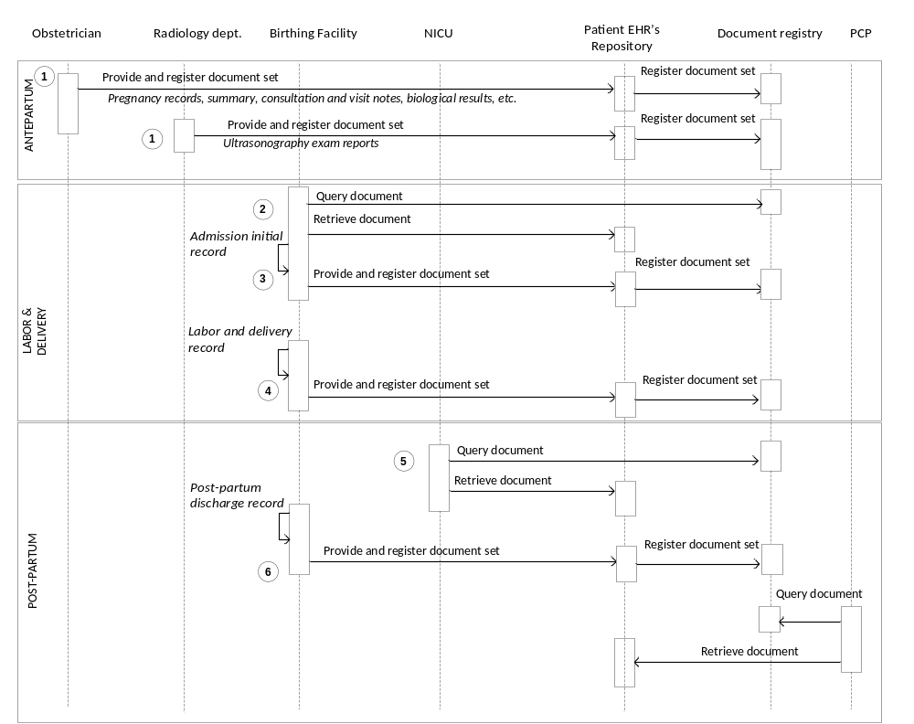

Figure X.2-1. Basic Process Flow in OB-LDP Profile

X.3 Grouping

X.3.1 Content Bindings with XDS, XDM and XDR
It is expected that the transfers of care will occur in an environment where the physician offices and hospitals have a coordinated infrastructure that serves the information sharing needs of this community of care. Several mechanisms are supported by IHE profiles:
- A registry/repository-based infrastructure is defined by the IHE Cross Enterprise Document Sharing (XDS) and other IHE Integration Profiles such as patient identification (PIX & PDQ) and notification of availability of documents (NAV).
- A media-based infrastructure is defined by the IHE Cross Enterprise Document Media Interchange (XDM) profile.
- A reliable messaging-based infrastructure is defined by the IHE Cross Enterprise Document Reliable Interchange (XDR) profile.
- All of these infrastructures support Security and privacy through the use of the Consistent Time (CT) and Audit Trail and Node Authentication (ATNA) profiles.
For more details on these profiles, see the IHE IT Infrastructure Technical Framework. Content profiles may impose additional requirements on the transactions used when grouped with actors from other IHE Profiles.

X.3.2 Cross Enterprise Document Sharing, Media Interchange and Reliable Messages
Actors from the ITI XDS, XDM and XDR profiles embody the Content Creator and Content Consumer sharing function of this profile. A Content Creator or Content Consumer must be grouped with appropriate actors from the XDS, XDM or XDR profiles, and the metadata sent in the document sharing or interchange messages has specific relationships to the content of the clinical document described in the content profile.

X.3.3 Notification of Document Availability (NAV)
A Document Source should provide the capability to issue a Send Notification Transaction per the ITI Notification of Document Availability (NAV) Integration Profile in order to notify one or more Document Consumer(s) of the availability of one or more documents for retrieval. One of the Acknowledgement Request options may be used to request from a Document Consumer that an acknowledgement should be returned when it has received and processed the notification. A Document Consumer should provide the capability to receive a Receive Notification Transaction per the NAV Integration Profile in order to be notified by Document Sources of the availability of one or more documents for retrieval. The Send Acknowledgement option may be used to issue a Send Acknowledgement to a Document Source that the notification was received and processed.
The Publish and Subscribe profile being developped this cycle may be considered when considering NAV.

X.3.4Document Digital Signature (DSG)
When a Content Creator Actor needs to digitally sign a document in a submission set, it may support the Digital Signature (DSG) Content Profile as a Document Source. When a Content Consumer Actor needs to verify a Digital Signature, it may retrieve the digital signature document and may perform the verification against the signed document content.

X.4 OB-LDP Security Considerations
<Description of the Profile specific security considerations. This should include the outcomes of a risk assessment. This likely will include profile groupings, and residual risks that need to be assigned to the product design, system administration, or policy.>

<Appendix A> Actor Summary Definitions
Content Creator - The Content Creator Actor is responsible for the creation of content and transmission to a Content Consumer.
Content Consumer – The Content Consumer Actor is responsible for viewing, import, or other processing of content created by a Content Creator Actor.

<Appendix B> Transaction Summary Definitions
Transactions are interactions between actors that transfer the required information through standards-based messages.

Volume 2 - Transactions

Add section 3.Y

3.Y <Transaction Name>
This section corresponds to Transaction Y of the IHE Technical Framework. Transaction Y is used by the <ABC> and <DEF> actors.

3.Y.1 Scope

3.Y.2 Use Case Roles
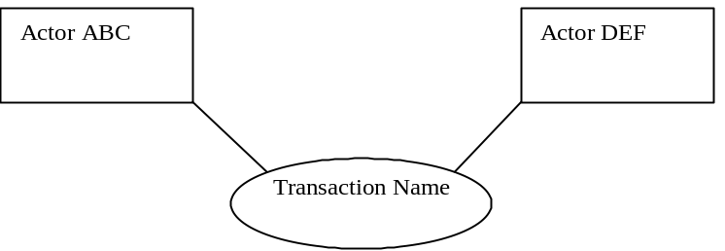

Actor:

Role:

Actor:

Role:

Actor:

Role: .

3.Y.3 Referenced Standard
<e.g., HL7 2.3.1 Chapters 2, 3>
<e.g. DICOM 2008 PS 3.3: A.35.8 X-Ray Radiation Dose SR IOD>

3.Y.4 Interaction Diagram
<the interaction diagram shows the detailed standards-based message exchange that makes up the IHE transaction>
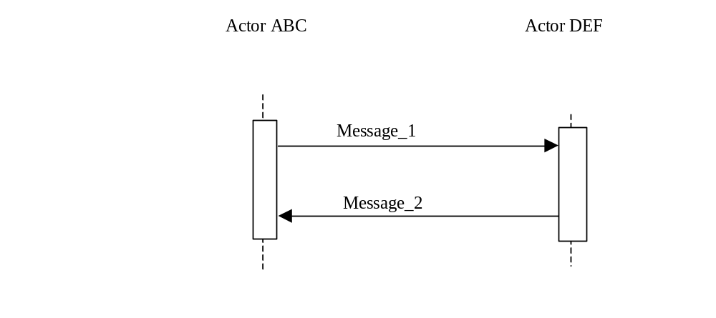

3.Y.4.1 <Message_1 Name>
<One or two sentence description of the first message of the above interaction diagram, typically relating the message to the relevant standard>

3.Y.4.1.1 Trigger Events
<description of the real world events that cause the initiation of the first message>

3.Y.4.1.2 Message Semantics
<detailed description of the meaning, structure and contents of the first message including any IHE specific clarifications of the message format, attributes, etc.>

3.Y.4.1.3 Expected Actions
<description of the actions expected to be taken as a result of sending or receiving this message>

3.Y.4.2 <Message_2 Name>
<One or two sentence description of the the next message in the above interaction diagram, typically relating the message to the relevant standard. Note, repeat this section as necessary based on the number of messages in the interaction diagram>

3.Y.4.2.1 Trigger Events
<description of the real world events that cause the initiation of the next message>

3.Y.4.2.2 Message Semantics
<detailed description of the meaning, structure and contents of the next message including any IHE specific clarifications of the message format, attributes, etc.>

3.Y.4.2.3 Expected Actions
<description of the actions expected to be taken as a result of sending or receiving this message>

3.Y.5 Security Considerations
<description of the transaction specific security consideration. Such as use of security profiles. >

3.Y.5.1 Security Audit Considerations
<This section should specifiy any specific ATNA security audit event that is associated with this transaction and requirements on the encoding of that audit event. >

3.Y.5.1.(z) Actor Specific Security Considerations
<This section should specifiy any specific security considerations on an Actor by Actor basis.>

<Appendix letter> Appendix_Name
<Detailed cross transaction relationships or mapping details are described in an appendix in Volume 2>

